PIRATE PARADE REGISTRATION FORM
Festival: Feb 15-18, 2018 featuring the
Pirate Parade on Saturday, Feb 17

FESTIVAL TICKETS REQUIRED
• All participants over the age of 10 must purchase a ticket to the Seafood & Music Festival.
- Seafood Festival Daily tickets are $8 each in advance on the Seafood Festival website or $10 on the day of the event at the gate.
  - Festival tickets do not include admission to the concerts with Don McLean, Willie Nelson and Los Lonely Boys. The festival ticket is good for all the other entertainment during the fun event.
  - Individual Concert ticket prices start at $20 for General Admission for one concert and include festival admission.
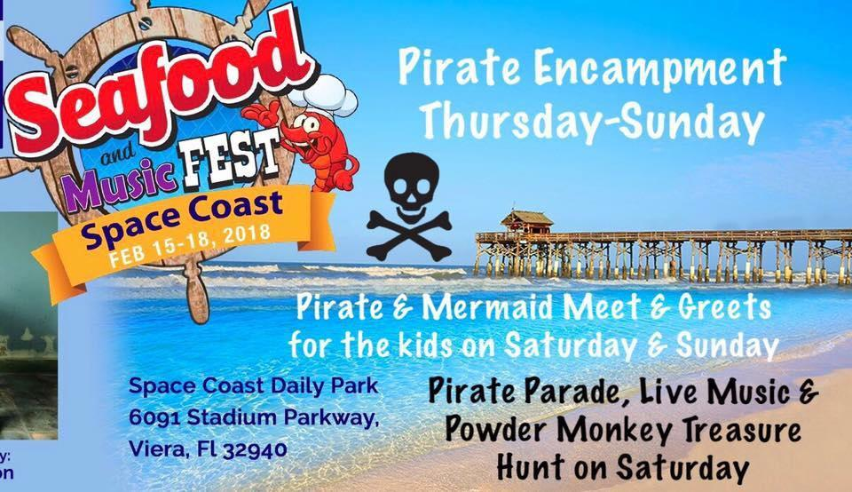
  - A four-day, Seafood Festival pass is just $29, which is good for all four days of the festival, but does not include the major concerts with Don McLean and Willie Nelson. It does include general admission access to the concerts with the Space Coast Symphony and The Wailers.
  - A 4-day, Concert pass is just $49 and is good for all four days of concerts and 4 days of access to the festival. All concert tickets include Seafood Festival access.
- Tickets can be purchased in person from Captain Panama Pearl in advance for only $8 cash. Don’t miss her arrrrrrsome Pirate Encampment at Brevard Renaissance Fair.

FULL PIRATE GARB/COSTUME REQUIRED
• All pirate crews, rogue pirates, pirate families of all ages, and scalawags who are new to pirating are invited to dress in full pirate garb and participate in the Pirate Parade & Party on Saturday 17th at 1pm during the Seafood & Music Fest. Pirate Entertainers must be in a full pirate costume to participate (not just a ripped up tee-shirt). Whether it’s a Party City pirate costume or a handcrafted period costume, all pirate fashions are welcome. If you are new to pirating and are not sure what qualifies as full pirate garb, visit www.facebook.com/brethrenofthespacecoast for photos.

COMPLIMENTARY DRINK TICKETS FOR PARADE PARTICIPANTS:
• Directly after the parade, registered parade participants can receive 1 complimentary Code Rum Pirate Punch cocktail drink ticket and get their hand stamped at the Brethren of the Space Coast booth. Drink tickets are good for a Pirate Rum Punch cocktail at the Code Rum booth. Drink tickets will be dispersed at the Brethren of the Space Coast booth directly after the parade and no later than 2:00 PM. Don’t be late, or you will miss out on the free grog. Costumed pirates who register to participate in the parade will receive 1 complimentary drink ticket (valued at $6). Must be 21 and over.
- Complimentary drinks are sponsored by Space Coast Daily and Code Rum.

PARADE SCHEDULE:
- 12:00 PM: Brethren of the Space Coast New Crew Member Inductions and Group Photo at Panama Pearl’s Pirate Ship
- 1:00 PM: Pirate Parade Begins at Panama Pearl's Pirate Encampment
- Directly after the parade and no later than 2:00 PM: Drinks tickets handed out at Brethren of the Space Coast booth in Panama Pearl’s Pirate Encampment

You may register as a couple or a family on one form. But you MUST include the full names of ALL participating pirates here:

Real Name(s) (required for drink ticket--please note any underage pirates)
___________________________________________________________________________
___________________________________________________________________________
___________________________________________________________________________

Pirate Name(s) (optional):
___________________________________________________________________________
___________________________________________________________________________
___________________________________________________________________________

Official Pirate Crew (if applicable): _____________________________________
City:________________________________________________ State:__________
Email
Address:_______________________________________________________________
Mobile Phone:______________________________________________

Are you interested in joining the Brethren of the Space Coast pirate fleet? ___________

Email completed form to Brethren of the Space Coast Yeoman Pirate Lizzie at piratelizzie@gmail.com by February 14, 2018.

